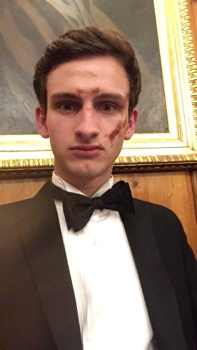

**Sam for Trea$urer 2.0**

# Who am I?

**I am:**

1. A third year Engineering undergraduate
2. A fully-fledged multi-award-winning rower of the 2017 NM2, 2018 M2 and 2019 M2 crews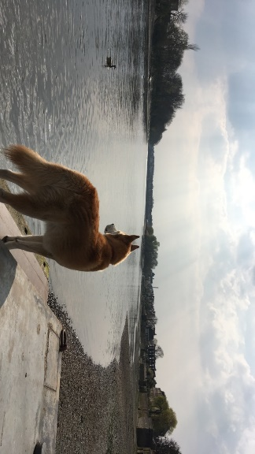
3. Proud to share the same name as our boathouse doggo, the goodest boi on the cam:

**I am not:**

1. As cool as our boathouse doggo (but being an engineer makes up for this)
2. A bowsider

# Why me?

1. “why change it if it ain’t broke” – would like to think I’m not broke
2. I’m personable, enthusiastic, organised, dependable, (insert other nice adjectives here)
3. I know all the lyrics to ‘row row row your boat’
4. I can eat a square of chocolate from my forehead without touching it (ask me to demonstrate at next BCD)
5. I love efficiency

# What I aim to do

1. Continue supporting other secretaries
2. 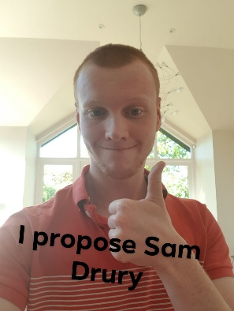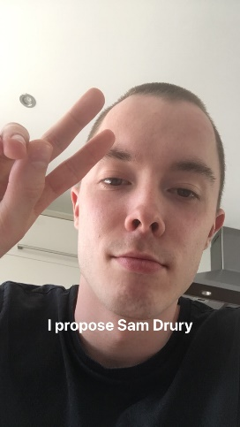Keep on top of treasurer duties and respond to matters promptly

Signed: Proposed: Seconded: